* **Features of the website**
  + A search box that allow you to search of books existed in database
    - 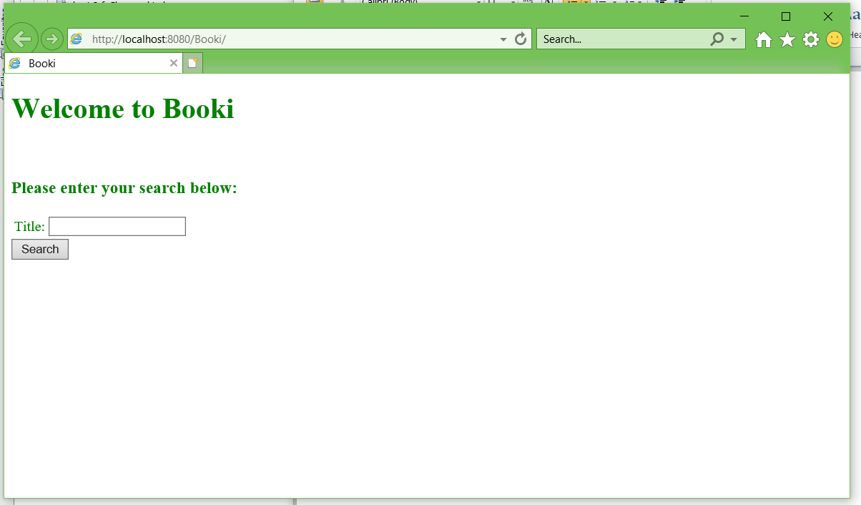
  + An page that allow you to add new book entry if it does not exist in the database
    - 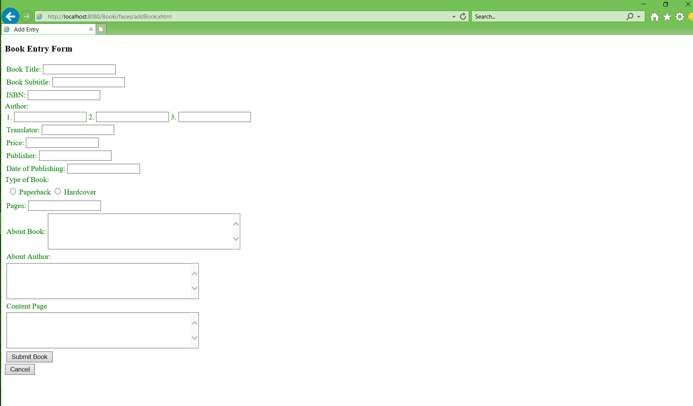
  + A page that allow you to view the books already in the database and make changes to them by pressing the edit button.
    - 